Name: ______________________________
Writing a Check
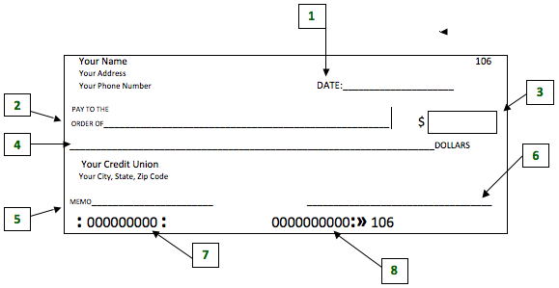
- Today’s date is May 18, 2015.
- Make the check out to Idylwild Elementary.
- The check is for $123.45.
- One hundred twenty-three dollars and 45/100
- For “Field trip”
- Sign your name.

Now, write a check of your own

